Dalton Murray

Human Computer Interaction

INT 3603 - 3452-202320_INT3603_OL

Professor Darren Hood

February 12, 2022

**Lab 3**

**(All images can be found and labeled here:** <https://drive.google.com/drive/folders/1bXWKnZkxKDuHzgHg9Ja5iDx8-Q9SpZ5a?usp=sharing>**)**

For this lab I wanted to try to use real-life examples of foreground/text color, and background colors which I have seen in use and then evaluate what I feel about them.

**Color Contrast Check 1**

Foreground – #FFFFFF

Background – #000000

Image –

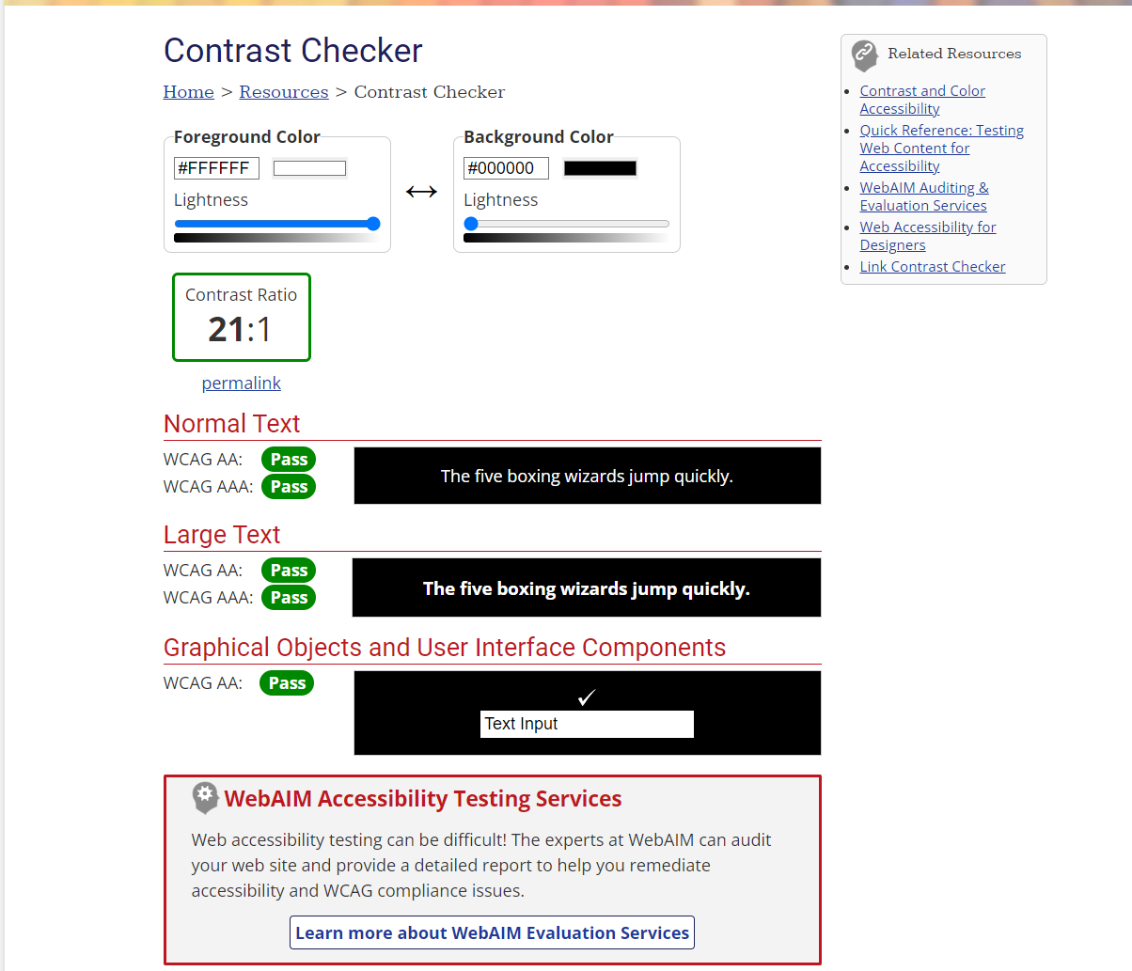

As a fan of dark themes this combination of full black background and full white text is almost ideal for me. I personally would like to have the text maybe a little darker/not as bright. However, this combination allows extremely easily viewable content on a page. This also feels more modern/up-to-date with todays stances on how websites should be viewed, as I personally am tired of going to a website that is extremely bright and having my eyes feel fatigued when I leave the website.

**Color Contrast Check 2**

Foreground – #FFFFFF

Background – #595959

Image –

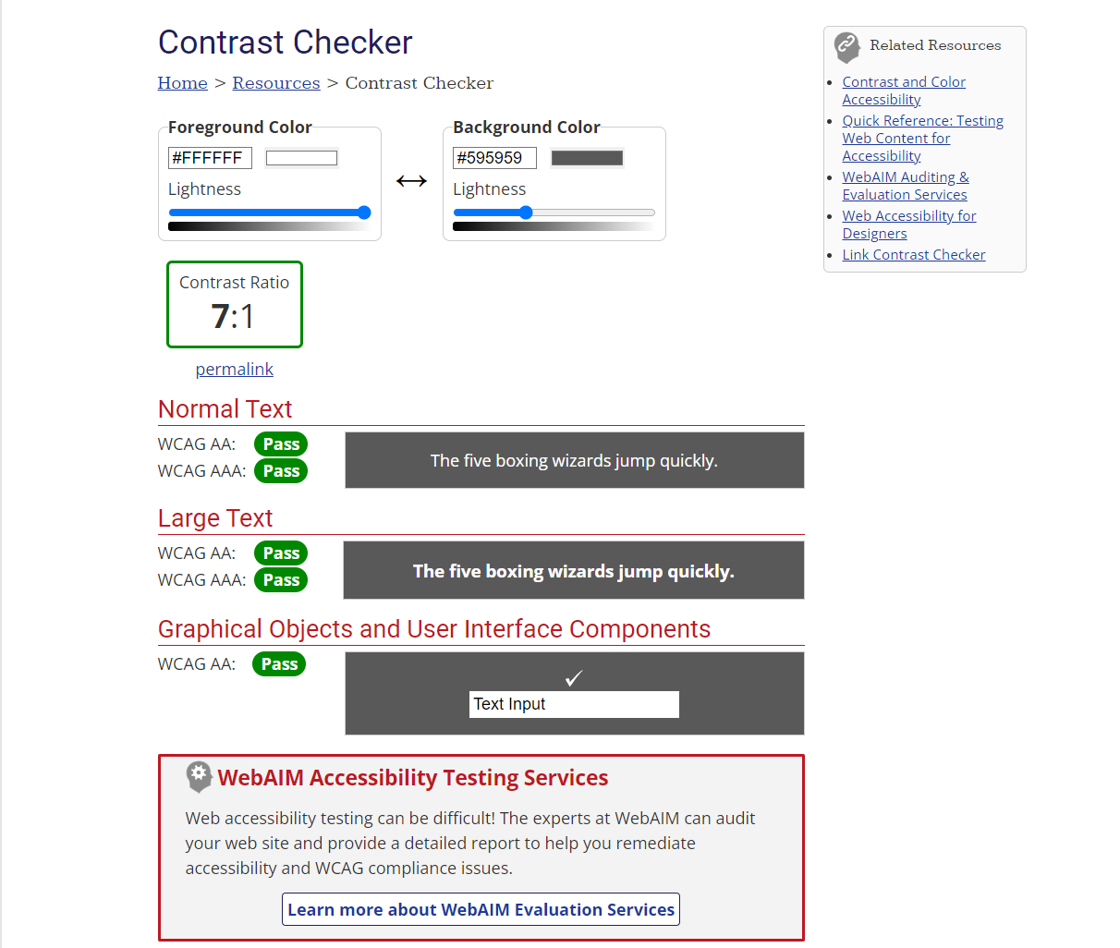

This specific combination has a lighter than black background with white text/foreground. I feel like this combination is good for people who don’t want to go all the way to full black background and may look better for older people and help transition them to viewing websites with a full black combination. The contrast here is nice as the text is distinct from the background to me and isn’t hard on the eyes like a full white background with black text or a lighter grey background with light text. It’s an ideal mixture between full dark mode and light mode.

**Color Contrast Check 3**

Foreground – #FFFFFF

Background – #C4C4C4

Image –

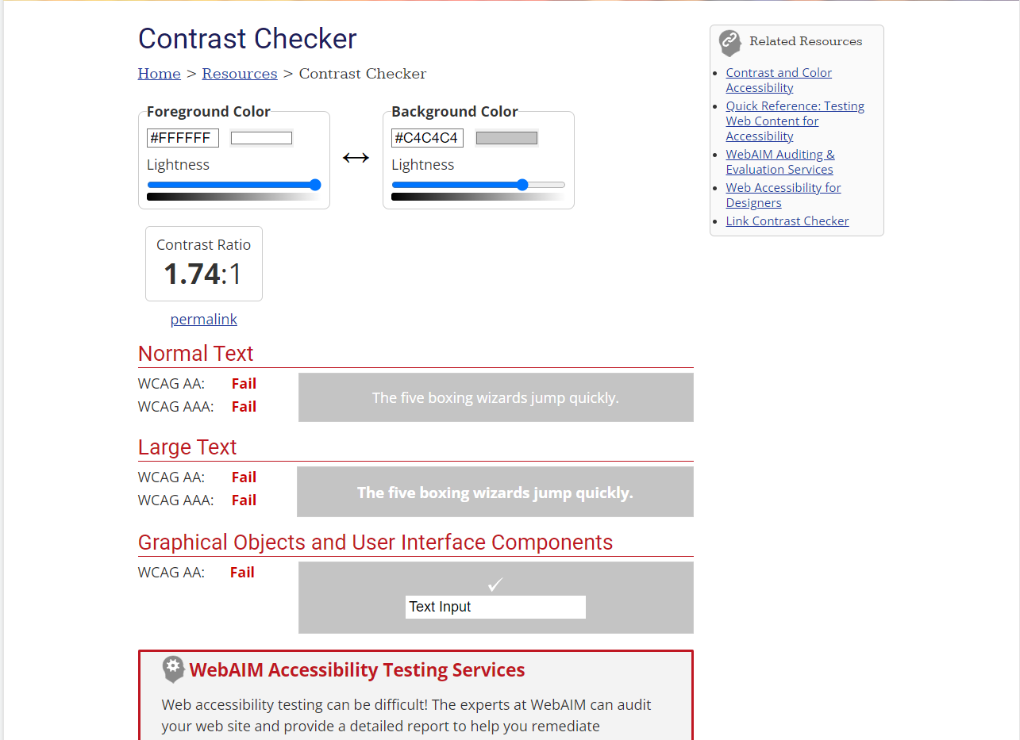

This combination is the combination that web designers try to use when they don’t want a dark theme and don’t necessarily want a light theme and can’t choose what to use. This is a very bad combination. The light grey is a decent color and could serve as a lighter than black mode theme but the foreground color being full white is terrible for contrast and readability.

**Color Contrast Check 4**

Foreground – #000000

Background – #EDEDED

Image –

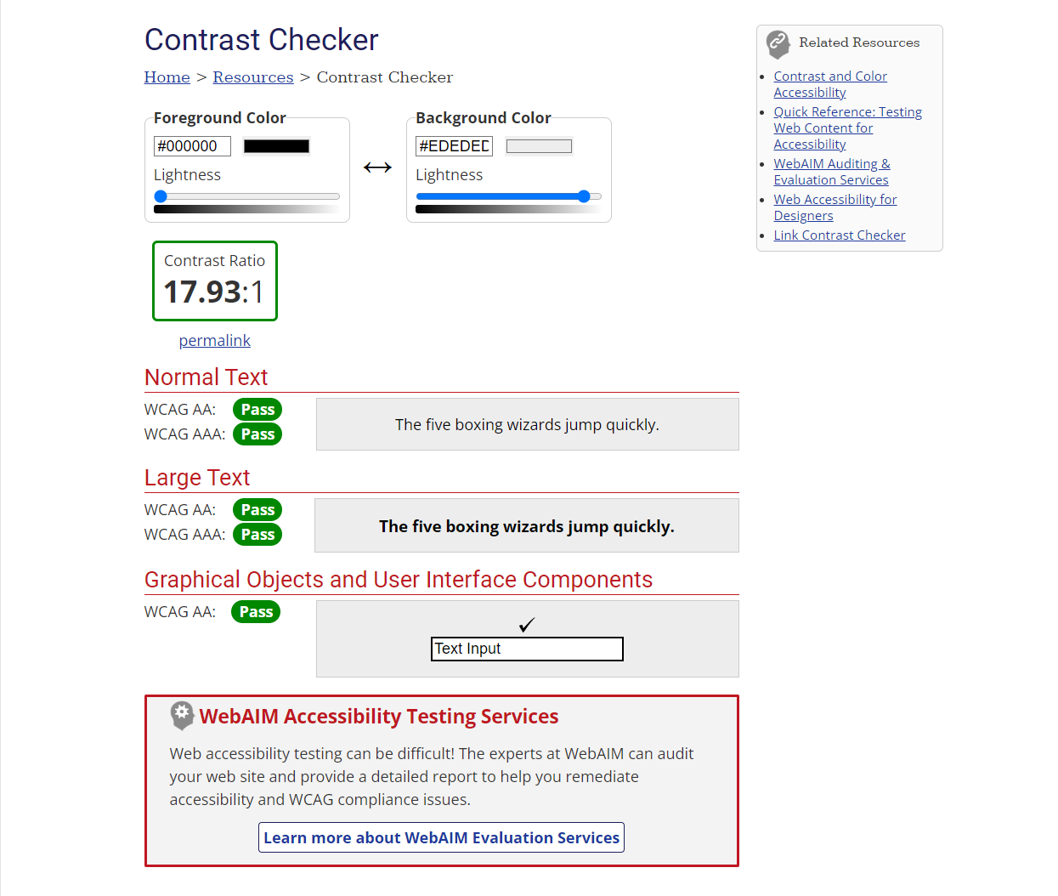

This combination of light grey background color and full black foreground color is great. I feel like no website should have a full white background and full black text color and if they don’t want to implement a dark mode should go with this or have a very small bit lighter grey background color. This combination is easy on the eyes and doesn’t strain eyes if on the website for a long time and is clearly readable. This is a theme I would also implement for older people who don’t like having a full dark theme or people with bad eyesight, or just if I feel like the website shouldn’t have a dark mode but shouldn’t be white.

**Color Contrast Check 5**

Foreground – #FFFFFF

Background – #001147

Image –

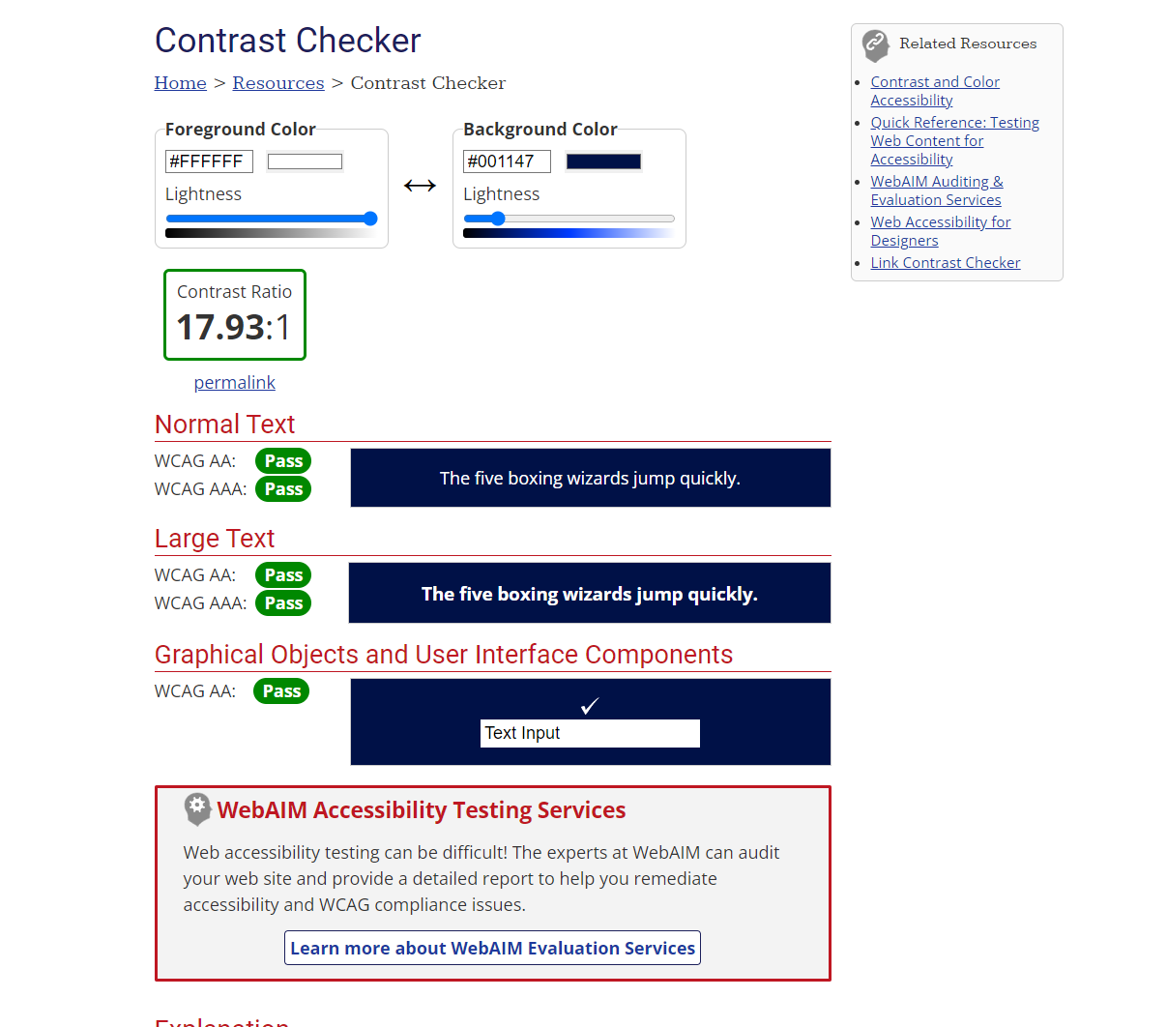

This combination is something more ‘modern’ and ‘stylish’ websites are using. It is a white foreground/text color on a very dark blue that is almost black. They will often use this in websites that have a header with a big image and text on it and other similar themes for ‘designers’. I feel like this can be done very well but can also be implemented poorly. Overall I think this combination is very readable and does look good.

**Honorable mentions**

**Color Contrast Check 6**

Foreground – #000000

Background – #E9F1FA

Image –

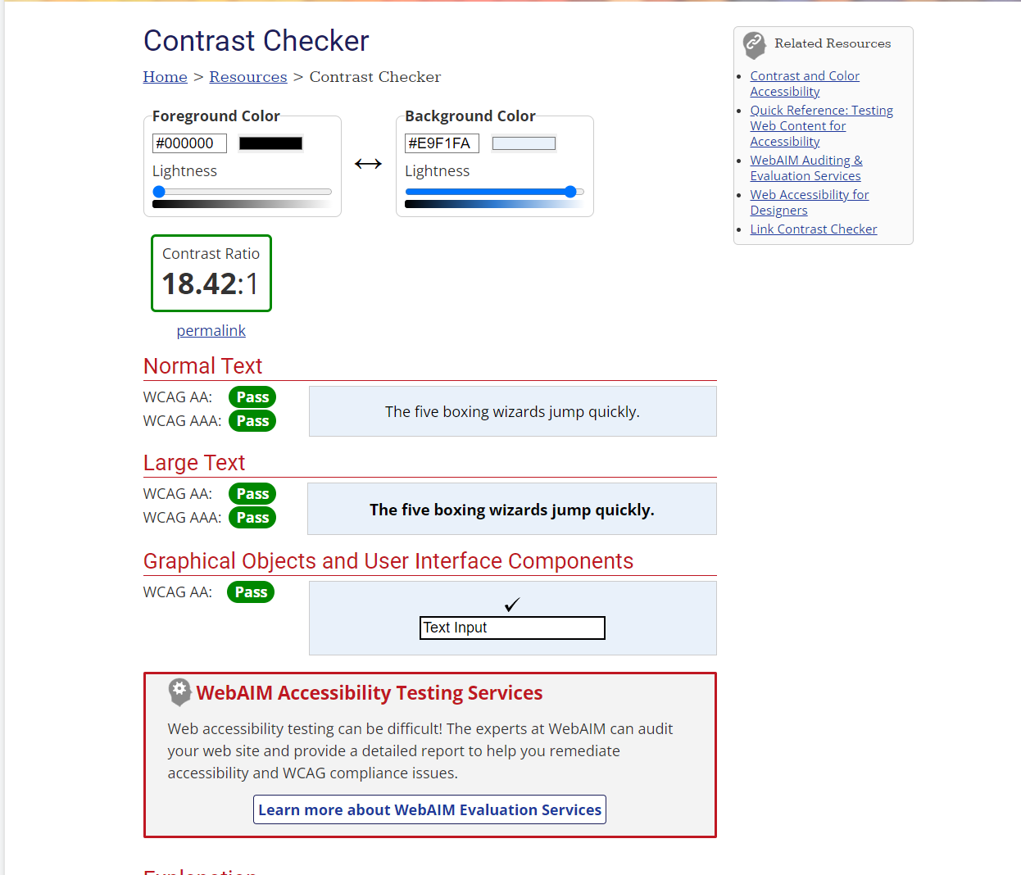

This combination of light blue background and full black is a classic combination and used in many websites today. It is easily readable, however, to me feels a little old and not up-to-date with standard colors.

**Color Contrast Check 7**

Foreground – #213F99

Background – #F2D4D6

Image –

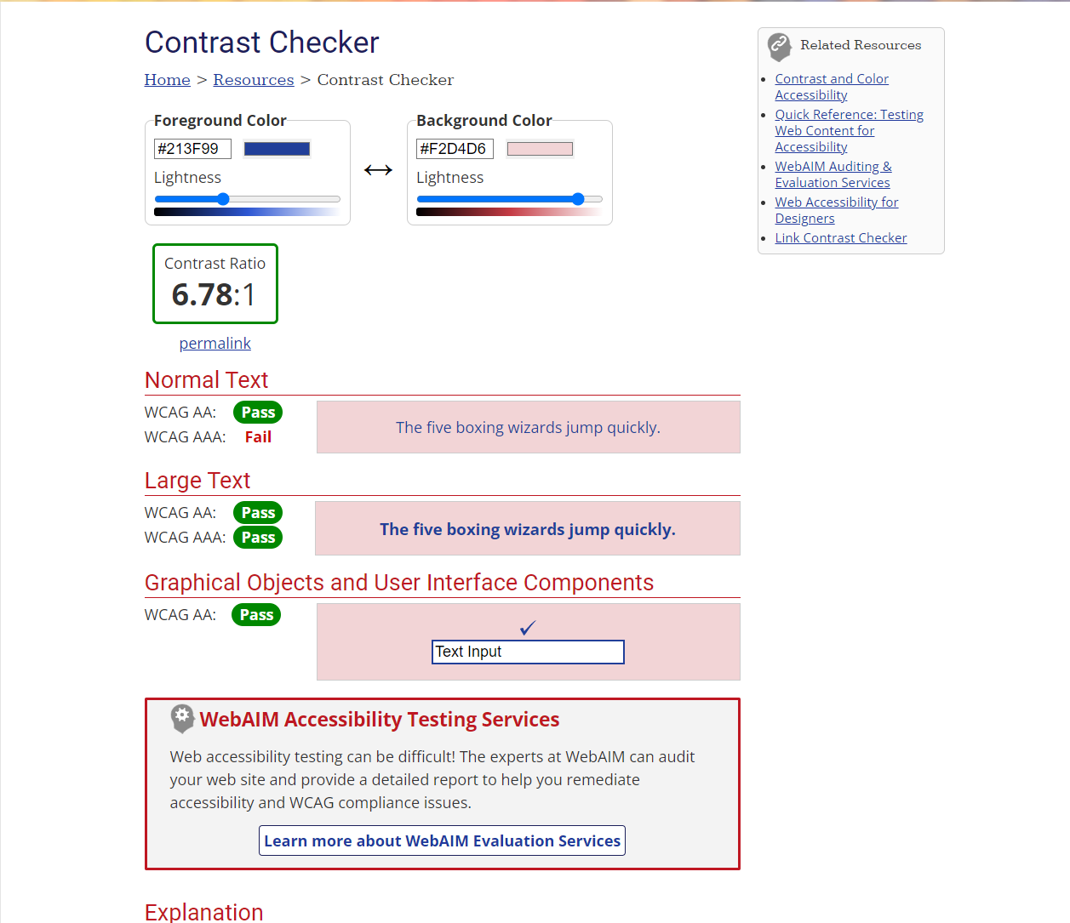

This combination of very light pink and blue is a very interesting combination to me. When I first looked at it in-use on a website I wasn’t sure if I liked it or not but it turned out how they were using it was good. This color combination, along with other brighter colors, are often used in fashion, jewelry, makeup, or designer like websites.

**Overall**

Many websites today are turning to a combination of a full black background and either a full white text/foreground or a lighter white foreground/text or having a darker grey/lighter grey background with a full white or darker foreground/text. I personally like this switch to having a full black background and white text as it feels more modern to me and reduces eyestrain caused by looking at something with a full white background and black text.

There are also many websites that are considering themselves more stylish/modern/designer like websites which are using different, interesting color combinations rather than the basic white, black, and grey which I also like if they do it well and the right way. I feel like designers need to find an interesting color combination that works well with their website.

Designers and developers of websites should also not only have one theme of colors but either have different set themes which people can pick from light a white/light theme, grey, and black themes, as well as high contrast themes. I also like websites that allow you to customize the colors yourself and save the colors to your profile.

I have neither given nor received unauthorized aid in completing this work, nor have I presented someone else's work as my own.

*Dalton Murray*